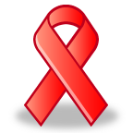
RED RIBBON WEEK October 22-26, 2018

MONDAY – Wild About Being Drug Free – Crazy Hair Day

TUESDAY – Show Your Pride Drug Free – Wear a Mills shirt or a red shirt.

WEDNESDAY – Tell Drugs to Take a Hike. Wear camping clothes.

THURSDAY – Don’t Get Tied Up in Drugs! Wear neckties, hair ties, tie dye shirts or just tie your shoes.

FRIDAY – Team Up Against Drugs – Wear your Hobbs Eagles shirts, Mills shirts, or your favorite team jersey.
