Dear Parents/Guardians,
This school year, all progress reports and report cards will only be available online. Below, please find the dates on which progress reports and report cards will be visible.
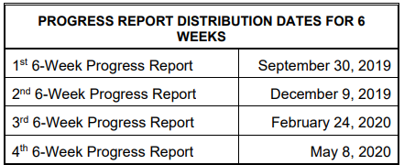
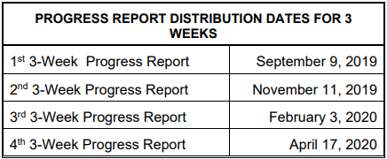

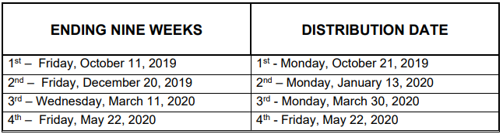
Below are the instructions on how to view and sign your student’s documents through your Family Access account. If you are unable to log into your Family Access account, please see Mrs. Julie in the office to verify your password and help troubleshoot any issues you may have. We appreciate our Mills parents and are thankful to have you as our partners in your student’s education.
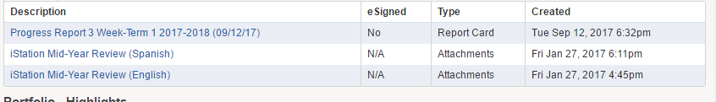
Step 2: You should see a list of available reports to view. Click on the report you want to view.
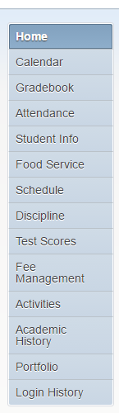
Step 1: Click “Portfolio” on the menu.

Step 3: Click “View Report” before signing. After viewing, back out and click the “I Agree” box. This will “Sign” your report. Click “Submit Signature” and your signature has been recorded with the school.
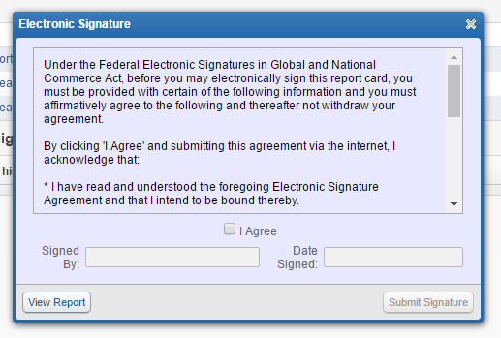
unable to be readunable to be read

